**Django MCQ Important questions**

1. Q: Which Django functions are used to take HTTP requests and return HTTP responses?

a) Models

**b) Views**

c) Templates

d) Admin

**Answer: b) Views**

2. Q: In Django, data is created in objects, what are these objects called?

a) Records

b) Fields

**c) Models**

d) Instances

**Answer: c) Models**

3. Q: How can you turn off debugging in Django's configuration file?

**a) Set `DEBUG = False` in settings.py**

b) Set `DEBUG = True` in settings.py

c) Run `python manage.py debug off`

d) It cannot be turned off

**Answer: a) Set `DEBUG = False` in settings.py**

4. Q: In Django's QuerySet, which method is used to get all the records and fields of a given model?

a) `get_all()`

b) `fetch_all()`

**c) `objects.all()`**

d) `model.get()`

**Answer: c) `objects.all()`**

5. Q: What is Django's forms module used for?

a) Handling URLs

b) Rendering templates

c) Handling user authentication

**d) Working with HTML forms**

**Answer: d) Working with HTML forms**

6. Q: How does Django protect against CSRF (Cross-Site Request Forgery) attacks?

a) By using strong passwords

b) By encrypting all HTTP requests

**c) By including a CSRF token in forms**

d) By blocking all external requests

**Answer: c) By including a CSRF token in forms**

7. Q: What is Django's security principle "Don't trust the client"?

a) Always trust user input

**b) Verify and sanitize user input**

c) Trust the client's JavaScript code

d) Only trust the server

**Answer: b) Verify and sanitize user input**

8. Q: How does Django handle user authentication?

a) It uses a separate authentication server

b) It relies on third-party authentication services

**c) It provides built-in authentication features**

d) It doesn't support user authentication

**Answer: c) It provides built-in authentication features**

9. Q: How does Django handle file uploads?

a) By storing files in plain text format

b) By using a third-party file storage service

**c) By providing built-in file upload handling**

d) By rejecting file uploads

**Answer: c) By providing built-in file upload handling**

10. Q: Which file is kind of your project local django-admin for interacting with your project via the command line?

**a) manage.py**

b) settings.py

c) urls.py

d) models.py

**Answer: a) manage.py**

11. Q: What happens when the urls.py file is edited while the development server is still running?

a) The server continues to run without any issues

**b) The server automatically restarts with the new URL patterns**

c) The server throws an error and must be manually restarted

d) The server pauses until the editing is complete

**Answer: b) The server automatically restarts with the new URL patterns**

12. Q: Which method is used instead of `path()` in `urls.py` to pass in regular expressions as routes?

**a) `re_path()`**

b) `regex()`

c) `match()`

d) `expression()`

**Answer: a) `re_path()`**

13. Q: What is the value of `DEBUG` when a Django website is online or deployed?

a) `True`

**b) `False`**

c) It depends on the server configuration

d) `DEBUG` is not relevant in a deployed environment

**Answer: b) `False`**

14. Q: Which of these commands is not a management command of `staticfiles`?

a) `collectstatic`

**b) `runserver`**

c) `findstatic`

d) `migrate`

**Answer: b) `runserver`**

15. Q: What data types and objects are not accepted as an argument by the `Paginator` class?

a) QuerySets

b) Lists

**c) Dictionaries**

d) Tuples

**Answer: c) Dictionaries**

16. Q: Which of these is not a valid method or approach to perform URL resolution in Django?

a) URL patterns defined in `urls.py`

b) Using the `resolve()` function

**c) Redirecting all URLs to the homepage**

d) Using regular expressions to match URLs

**Answer: c) Redirecting all URLs to the homepage**

17. Q: What are `request.GET` and `request.POST` objects in Django?

a) They store session data

b) They contain user authentication details

c) They handle file uploads

**d) They hold data from GET and POST requests, respectively**

**Answer: d) They hold data from GET and POST requests, respectively**

18. Q: Which of the following Password Validators are not provided by default in Django?

a) CommonPasswordValidator

b) MinimumLengthValidator

c) NumericPasswordValidator

**d) StrongPasswordValidator**

**Answer: d) StrongPasswordValidator**

19. Q: What is Django's middleware in web development?

a) A security feature for client-side validation

b) A tool for managing database migrations

**c) A framework for creating custom request/response processing**

d) A user authentication library

**Answer: c) A framework for creating custom request/response processing**

20. Q: What is the purpose of the "__init__.py" file in Django?

a) It's a main configuration file for Django projects

**b) It indicates that the directory is a Python package**

c) It defines the structure of the project's database

d) It stores the project's secret key

**Answer: b) It indicates that the directory is a Python package**

21. Q: What is the purpose of the "migrations" folder in Django?

a) It contains static files for the project

**b) It manages database schema changes over time**

c) It stores Django templates

d) It is used for URL routing

**Answer: b) It manages database schema changes over time**

22. Q: What is the purpose of the "settings.py" file in Django?

a) It defines URL patterns for the project

b) It stores the project's HTML templates

**c) It contains the project's configuration settings**

d) It defines models for the database

**Answer: c) It contains the project's configuration settings**

23. Q: How do you make a URL pattern in Django?

a) By using HTML tags

b) By configuring it in the web server

**c) By defining it in the `urls.py` file**

d) By using Python decorators

**Answer: c) By defining it in the `urls.py` file**

24. Q: Which file is used if you need to deploy your project over WSGI?

a) `manage.py`

b) `settings.py`

**c) `wsgi.py`**

d) `urls.py`

**Answer: c) `wsgi.py**

25. Q: `render` function takes how many parameters?

a) 1

b) 2

**c) 3**

d) 4

**Answer: c) 3 (request, template_name, and context)**

26. Q: What kind of non-HTML outputs can Django generate?

a) HTML only

b) XML only

**c) JSON, XML, and more**

d) PDF only

**Answer: c) JSON, XML, and more**

27. Q: Which of the following is a valid database supported by Django?

a) MongoDB

**b) SQLite**

c) Redis

d) All of the above

**Answer: b) SQLite**

28. Q: Which command is used to create a new Django project?

a) `python createproject.py`

**b) `django-admin startproject`**

c) `python manage.py createproject`

d) `start-django-project`

**Answer: b) `django-admin startproject`**

29. Q: What is the purpose of the `django-admin` command in Django?

a) To create Django models

b) To start the development server

**c) To manage Django projects and applications**

d) To define URL patterns

**Answer: c) To manage Django projects and applications**

30. Q: Which module is used to work with forms in Django?

**a) `forms.py`**

b) `templates.py`

c) `views.py`

d) `models.py`

**Answer: a) `forms.py`**

31. Q: What does the `Django ORM` stand for?

**a) Object-Relational Mapping**

b) Object-Request Model

c) Object-Render Model

d) Object-Response Mapping

**Answer: a) Object-Relational Mapping**

32. Q: Which Django command is used to create a new Django app?

a) `python createapp.py`

**b) `python manage.py startapp`**

c) `django-admin createapp`

d) `start-django-app`

**Answer: b) `python manage.py startapp`**

33. Q: What is the purpose of the `migrations` in Django?

a) To migrate data between databases

**b) To manage database schema changes over time**

c) To create static HTML files

d) To define URL routing

**Answer: b) To manage database schema changes over time**

34. Q: What is the role of the Django template system?

a) To define database models

b) To create and manage user sessions

**c) To define the structure and layout of web pages**

d) To handle user authentication

**Answer: c) To define the structure and layout of web pages**

35. Q: Which database model field type is used to store a URL?

**a) `URLField`**

b) `CharField`

c) `TextField`

d) `URLType`

**Answer: a) `URLField`**

36. Q: What is the primary purpose of Django's middleware?

a) To define URL patterns

**b) To process and modify HTTP requests and responses**

c) To manage database migrations

d) To create custom authentication backends

**Answer: b) To process and modify HTTP requests and responses**

37. Q: In Django, what is the purpose of the `__str__` method in a model?

a) To define the structure of a database table

b) To specify which fields are editable in a form

**c) To return a human-readable representation of the object**

d) To define the structure of a URL pattern

**Answer: c) To return a human-readable representation of the object**

38. Q: What is the role of the `SECRET_KEY` in Django's settings?

a) It's used to encrypt user passwords

b) It's a unique identifier for database records

**c) It's used to sign cookies and sessions**

d) It's the URL of the development server

**Answer: c) It's used to sign cookies and sessions**

39. Q: In Django, what is a context processor?

a) A function that modifies request headers

**b) A function that processes template context data**

c) A function that authenticates users

d) A function that manages database transactions

**Answer: b) A function that processes template context data**

40. Q: Which of the following is not a valid URL pattern example in Django?

a) `path('articles/', ArticleListView.as_view())`

b) `re_path(r'^articles/(?P<slug>[\w-]+)/$', ArticleDetailView.as_view())`

**c) `url('articles/', ArticleListView.as_view())`**

d) `path('articles/', include('articles.urls'))`

**Answer: c) `url('articles/', ArticleListView.as_view())`

**In Table Forms**

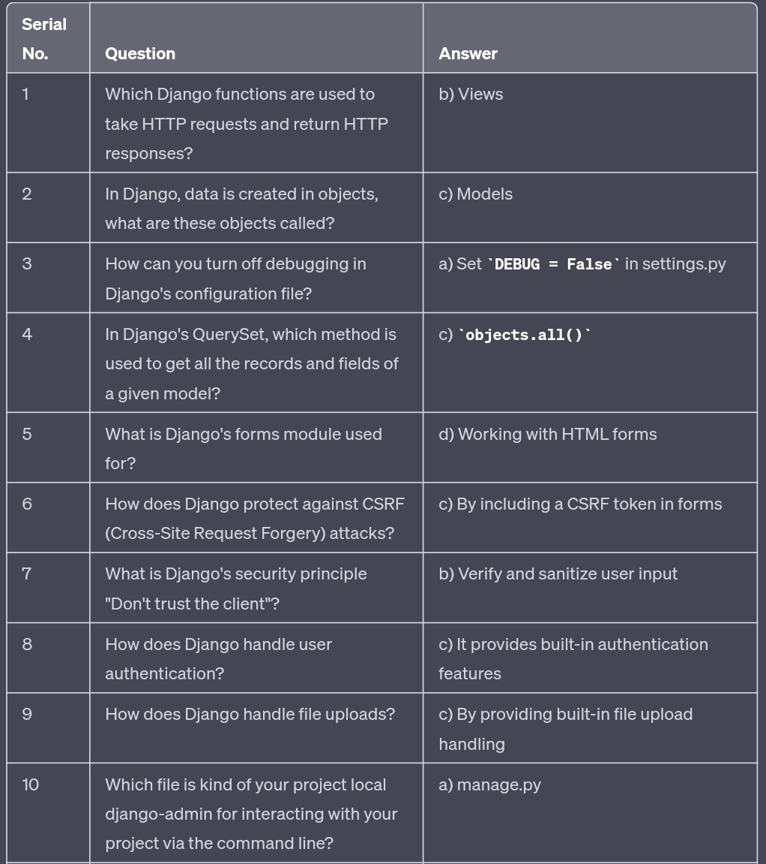

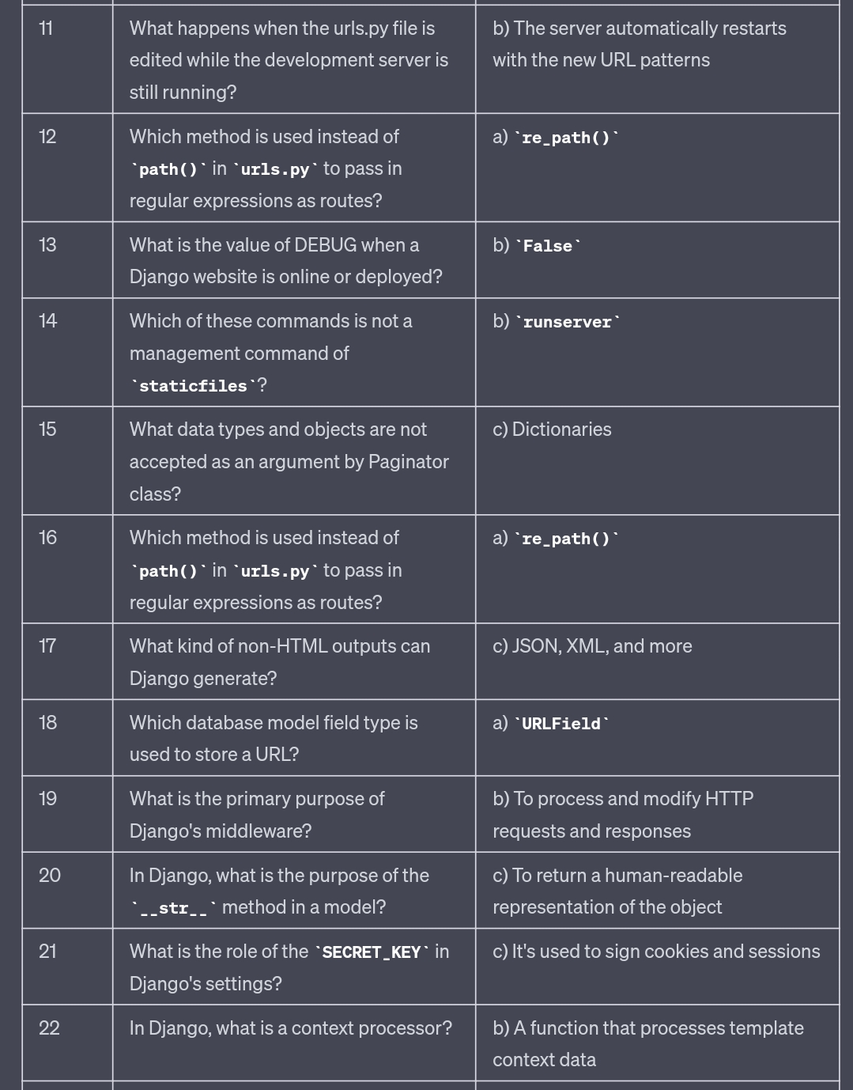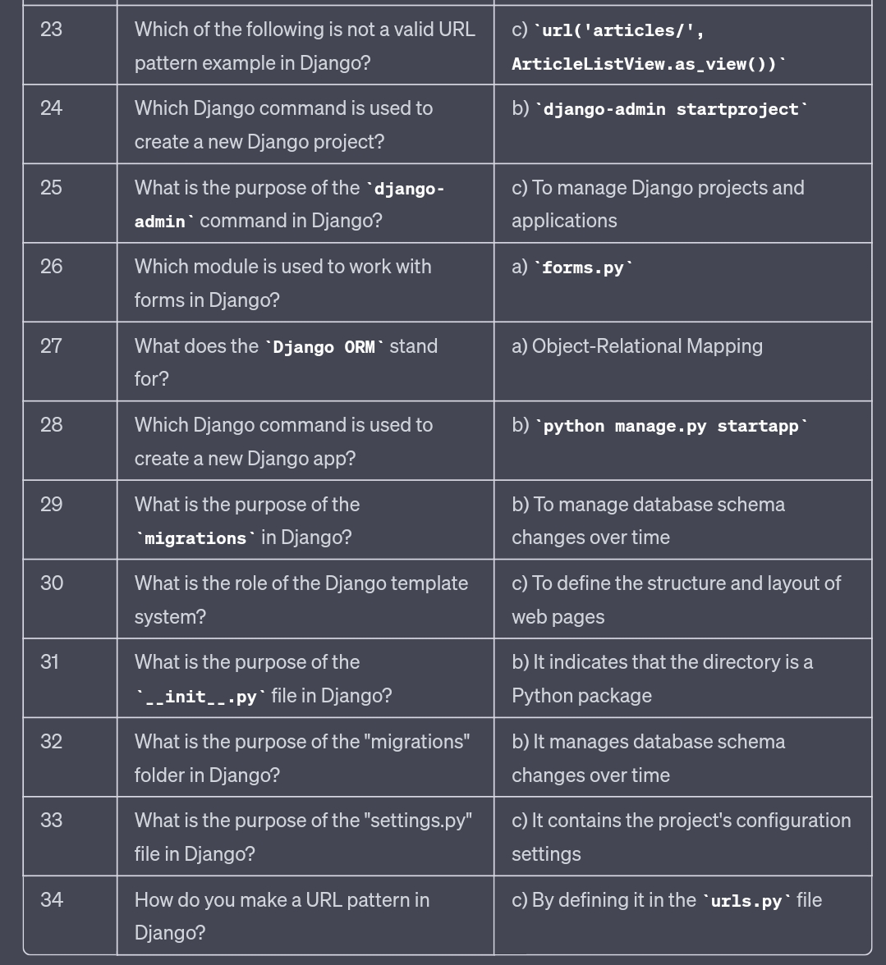

**Python Web Development using Django QUIZ 2**

1.What is Django used for ?

Machine learning

Game development

**Web development**

Data analysis

2.What is Django in python ?

**framework**

A library

A function

A script

3.What is the base principle of MVT in Django ?

Model, Template, View

**Model, View, Template**

Template, Model, View

Template, View, Model

4. What is the default database used in Django ?

Oracle

**SQLite**

PostgreSQL

MySQL

5.What does the Django ORM (Object-Relational Mapping) do ?

**Maps objects to relational database tables**

Maps relational database tables to objects

Provides data validation

Manages database connections

6. What is Django's template language used for ?

Data validation

URL routing

**Dynamic HTML generation**

Object-Relational Mapping

7.What is Django's staticfiles app used for ?

**Serving static files like images, CSS, and JavaScript**

Generating dynamic HTML

Handling user authentication

Storing data in cache

8. How does Django protect against CSRF (Cross-Site Request Forgery) attacks ?

By using a secret key

By using SSL/TLS

**By using a unique token for each request**

By using a fixed path

9.What is the preferred way to start a new Django project ?

Manually creating all necessary files and directories

**Using the Django startproject command**

Copying an existing project

Using a code editor's project template

10.What is the purpose of Django's manage.py file ?

**To run the development server**

To manage project-level configuration and tasks

To handle URL routing

To serve static files

11.What is the purpose of Django's asgi module ?

**To enable Django to work with asynchronous code**

To handle URL routing

To serve static files

To manage project-level tasks

12.How do you create a Django project ?

**django-admin startproject projectname**

django-admin createproject projectname

django startproject projectname

django createproject projectname

13.What is a Django app ?

A standalone software

**A component of a project**

A database

A programming language

14. What is the purpose of the "urls.py" file in Django ?

**To store the project's URL configurations**

To store project-level settings

To store app-level settings

To store the project's static files

15. How do you make a Django model available for use in the admin interface ?

**By registering the model in the "admin.py" file of the app**

By registering the model in the "settings.py" file of the project

By registering the model in the "models.py" file of the app

By registering the model in the "urls.py" file of the project

16.What is the purpose of the "views.py" file in Django ?

To store the project's URL configurations

To store the project's models

To store the project's static files

**To store the project's views**

17.What is the purpose of the "settings.py" file in Django ?

To store app-level settings

**To store project-level settings**

To store the project's URL configurations

To store the project's static files

18.How do you run the development server in Django ?

**python manage.py runserver**

python runserver manage.py

django runserver

django manage.py runserver

19.What is the purpose of the "init.py" file in Django ?

To store the app's models

To store the app's views

**To initialize the app**

To store the app's forms

20.How do you run database migrations in Django ?

**python manage.py migrate**

python migrate manage.py

django migrate

django manage.py migrate database

Submit